JVM Architecture:
JVM stands for java virtual machine.
As we all know java is a high-level language.
Before going to JVM Architecture we will go through how we will get .class file.
Source code(.java file) ----→ compiler(Javac) ----→ Byte code(.classfile)

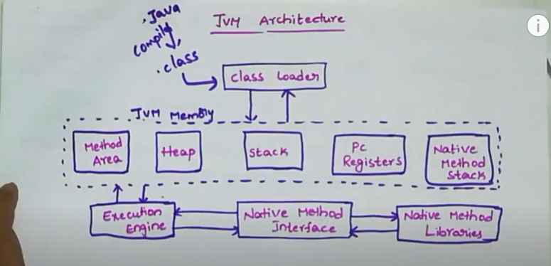
As we know classloader loads the .class file into it and we have three different types of classloaders(performs loading, linking and initialization).
Linking performs verification, preparation.
- Ensures the correctness of the .class file. Checks whether the file is properly formatted and generated by compiler or not.
- Verification fails we will get the runtime exception(java.lang.VerifyError).
- JVM gives the memory to the static and default variables.
Initialization:
All static variables are assigned to the values defined in the code.
Bootstrap class loader:
Loads core java API classes present in the “JAVA_HOME/jre/lib” directory.
Extension class loader:
Child of bootstrap class loader loads the classes present in the extensions directories.

System/Application class loader:
It is a child of the extension class loader. It is responsible to load classes from the application classpath. It internally uses Environment Variable

JVM follows the Delegation-Hierarchy principle to load classes.
First it will delegate the request to the system class loader and then it delegate the request to the extension class loader and then the bootstrap class loader. If the class Is found then the class is loaded otherwise request again transfers to the next step and finally if it fails we will get the exception.

2. JVM Memory Areas:
Method area: class names, variables info are stored.
Heap area : Objects gets stored
Stack area : Temparory variables and the references to the objects are stored.
PC registers: Stores address of the current execution instruction. Each thread has the separate registers.
Native method stacks: For every thread, a separate native stack is created. Stores native method info.
3. Execution Engine:
Execution engine executes the “.class” (bytecode). It reads the byte-code line by line,
- Interpreter: It interprets the bytecode line by line and then executes. The disadvantage here is that when one method is called multiple times, every time interpretation is required.
- Just-In-Time Compiler(JIT) : It is used to increase the efficiency of an interpreter. It compiles the entire bytecode and changes it to native code so whenever the interpreter sees repeated method calls, JIT provides direct native code for that part so re-interpretation is not required, thus efficiency is improved.
5. Java Native Interface (JNI)
It is an interface that interacts with the Native Method Libraries and provides the native libraries(C, C++) required for the execution. It enables JVM to call C/C++ libraries and to be called by C/C++ libraries which may be specific to hardware.

6. Native Method Libraries
These are collections of native libraries required for executing native methods. They include libraries written in languages like C and C++.

